**Multilevel Meta-Analysis and Probabilistic Population-Wide Health Risk Assessment of Dietary Pesticide Exposure in Ethiopia**

*Asefa et al.*

***Evidence before this study***

***Added value of this study***

***Implications of all the available evidence***

***Why even this study?***

Geographical biases in global food safety research skew understanding and policy toward high-income regions, perpetuating exposure and risk disparities that disproportionately burden the Global South, where inadequate monitoring and weak regulations leave the true magnitude of pesticide hazards unquantified. Sparse literature data can be synthesized via systematic review and meta-analysis in such settings, but conventional methods falter on hierarchical structures, left-censorship, missing data, variabilities, and uncertainties. To bridge these gaps, our study developed a novel multilevel meta-analytic Monte Carlo-based probabilistic risk assessment framework, modeling data dependencies and propagating uncertainties to generate robust, population-level dietary pesticide risk distributions, while employing state-of-the-art imputation for non-detects and missing values.

***Abstract***

This study introduces a novel meta-analytic–stochastic framework integrating multilevel meta-analysis (MMA) with Monte Carlo-based probabilistic risk assessment (MC-PRA) to estimate nationally representative pesticide residue levels in Ethiopian foods and quantify chronic population-wide health risks. Drawing from 40 studies encompassing 18,298 samples across 87 pesticides and 18 food groups, we addressed data challenges like hierarchical clustering, left-censorship, and missing values using advanced techniques (e.g., Kaplan-Meier imputation, multivariate imputation by chained equations). Applied to Ethiopia, a data-limited Global South context with heavy pesticide reliance but weak monitoring, the framework tested hypotheses on residue variations, moderators (e.g., food origin, location), and risk levels, revealing elevated exposures and providing a replicable model for equitable global food safety assessments. All analyses were conducted in R, with open-source data and scripts for transparency.

***Results and discussion, and interpretations:*** xx

# Background

Pesticides are essential for boosting agricultural productivity, yet their toxicity threatens human health and environmental integrity. Globally, nearly two-thirds of agricultural land faces pesticide pollution risks, particularly in biodiversity hotspots and the Global South (Tang *et al.*, 2021), with an estimated footprint of 2 gigatons of body weight equivalent (Tang *et al.*, 2022). Dietary intake is considered the main pathway of general population exposure to pesticides, and it is associated with a range of health effects, including neurodevelopmental disorders, endocrine disruption, and cancers (Beyuo *et al.*, 2024; Kim *et al.*, 2017; Yang *et al.*, 2024). Regulatory agencies aim to mitigate these risks by establishing maximum residue limits (MRLs), which set the legally acceptable levels of pesticide residues in food (Handford *et al.*, 2015).

Food safety concerns are escalating worldwide, but exposure and enforcement disparities persist. In the European Union, nearly half of foods lack detectable pesticide residues, with 98% complying with limits (Carrasco Cabrera *et al.*, 2024). Similarly, in the United States, 40% of foods are residue-free, and over 99% meet standards (USDA, 2024). In contrast, residue detections in food, including banned highly hazardous pesticides (HHPs), are widespread and often exceed limits in the Global South. For example, detection frequencies reaching up to 100% were reported in Africa, the Middle East, Asia, and Latin America, with non-compliance rates of 100%, 78%, 61%, and 41%, respectively (Tang *et al.*, 2025). Yet, studies addressing the issue are sparse, and findings are inconsistent or conflicting. For instance, although residue detection was relatively low (29%) in Bangladesh, high exceedance (73%) was reported (Khatun *et al.*, 2023); similarly, exceedance reached 70% in Pakistan (Abbas et al., 2024) and 40% in Uganda (El-Sheikh et al., 2022). In Brazil, 30% of EU-banned pesticides remain in use, often at MRLs 400 times higher (Perobelli, 2025). Tang et al. (2025) concluded that over one-third of domestically produced foods in Africa are unsafe due to pesticide contamination. However, Ingenbleek et al. (2020) found that foods in multiple African countries are generally safe from pesticide risks, except for chlorpyrifos in smoked fish.

Overall, these evident disparities leave the Global South, home to over 80% of the world’s population, facing the highest burdens, even though the true magnitude of exposure and associated health risks largely remains unquantified. Additionally, existing geographical biases in the global understanding of food safety continue to skew policy toward high-income regions. These factors, combined with the highlighted data inconsistencies, indicate an urgent need for harmonized, context-specific analyses.

Systematic review and meta-analysis methodologies can be leveraged in data-limited settings to compile exposure data for use in dietary risk assessments and to inform regulatory decision-making (Whaley *et al.*, 2016; WHO/FAO, 2009). However, these methodologies are severely limited in application, especially when conventional approaches are used. Traditional meta-analysis methods fail to handle hierarchical clustering (e.g., non-independence due to study, region, or method) (Nakagawa, Yang, *et al.*, 2023), left-censorship (i.e., non-detects below detection limits) (Helsel, 2006), and missing values (Nakagawa and Freckleton, 2008), which are typical of environmental exposure data. Moreover, translating these data into population-level risks demands handling variabilities (e.g., difference in individual’s daily intake or response) and uncertainties (e.g., error in measurement or data gap), which deterministic methods inadequately address (Flinders *et al.*, 2025; US EPA, 2014). To surmount these barriers, we developed a novel meta-analytic–stochastic framework integrating multilevel meta-analysis (MMA) with Monte Carlo-based probabilistic risk assessment (MC-PRA). MMA estimates nationally representative residue levels by accounting for data hierarchies and dependencies, while MC-PRA provides realistic risk distributions by incorporating variabilities and uncertainties.

We applied this framework to Ethiopia, a typical Global South country with a population of 120 million (the second most populous in Africa) and an agrarian-led economy. Ethiopia relies heavily on pesticides, ranking among the top consumers in Africa, and usage is expected to increase with ongoing agricultural expansion (Asefa, Mergia, *et al.*, 2024; Gentil *et al.*, 2020). Yet, the country only enacted pesticide legislation in 2010 (Proclamation 674/2010), and existing regulatory risk assessments are confined to surface water exposure (Asefa, Damtew, *et al.*, 2024; Teklu *et al.*, 2015). Moreover, there is no systematic monitoring or management of residues in domestically consumed or exported foods, though emerging studies underscore significant concerns (Daba *et al.*, 2011; Dinede *et al.*, 2023; Mekonen *et al.*, 2015; Mengistu *et al.*, 2025).

In this context, we compiled pesticide residue data from 40 studies encompassing 18,298 samples, 87 pesticides, and 18 food groups, and tested three main hypotheses: (i) residues are elevated and vary by pesticide use and food type; (ii) predictors include food origin, location, and method; and (iii) population risks range from low to moderate. This is the first study of its kind to provide a comprehensive national-scale estimate of dietary pesticide exposure in Africa. Beyond its immediate findings, the study offers a replicable, data-driven framework for dietary pesticide risk assessment that is adaptable to other Global South contexts. By addressing systemic data gaps, this work supports evidence-based policymaking and contributes to more equitable and effective global food safety governance.

# Methods

## Methodological Overview

Our comprehensive, multi-method framework comprised five key steps: (1) systematic literature search, (2) data compilation and processing, (3) imputation and censoring treatment, (4) multilevel meta-analysis, and (5) exposure and risk characterization. From an extensive search of international and local databases, we included 40 studies reporting 2,271 unique residue measurements, and summarized our dataset characteristics. To address the high proportion of left-censored and missing data, we applied a combination of statistical techniques, ranging from simple substitution to multiple imputation. MMA models with robust variance estimation (RVE) were employed to account for sampling dependencies and minimize small-study bias. Uni-moderator models were used to explore sources of heterogeneity, and stratified random-effects models (n = 251) were fitted to estimate pooled residue levels for pesticide-food pairs. Chronic dietary risks were computed using Monte Carlo simulations with Latin hypercube sampling (n = 10,000), incorporating distributions of pesticide residues, national food consumption data, adult body weight, and toxicological reference values.

## Data Compilation and Preprocessing

A systematic search was conducted across 13 international and local databases, including gray literature sources, to identify studies reporting pesticide levels in various matrices (e.g., air, water, food) in Ethiopia, with the goal was to support a national-scale, multi-pathway, multi-pesticide exposure and cumulative risk assessment. For the purpose of this study, we included 40 eligible studies that reported non-duplicate, quantitative data on pesticide residues in food from the compiled comprehensive articles database (see SI Section 1 for details). Briefly, searches were conducted across Web of Science, Scopus, PubMed, Google Scholar, Semantic Scholar, OpenAlex, OAIster, and six Ethiopian university repositories. Our search strategy used combinations of terms related to pesticides, exposure and Ethiopia, which was validated against a pre-defined benchmark set of 35 studies (Lagisz *et al.*, 2025). All retrieved records were deduplicated using the *synthesisr* R package (Westgate and Grames, 2020) and screened using Rayyan (<https://rayyan.ai/>). Finally, records were tagged by matrix type (e.g., air, water, food), and only those reporting food pesticide residues were included here.

Metadata, including sampling region, food type, analytical method, and detection limits, were extracted alongside statistical residue summaries (e.g., means, standard deviations, medians). The final dataset consisted of 2,271 effect sizes across 87 pesticides, 18 food types (including drinking water), 8 regions, and 15 zones, totaling 18,298 samples (SI Section 2). The dataset characteristics were explored and summarized using the meta-analysis enrichment workflow outlined by Yang *et al.* (2025). Furthermore, to prepare the dataset for analysis, we evaluated missingness, assessed residue distributions, identified the best-fitting distribution, and removed extreme outliers. Pesticide types other than insecticides, herbicides, or fungicides were excluded (n=8). We also removed 172 outliers and found that a lognormal distribution best fit the residue data.

## Handling Left-Censoring and Missing Data

Approximately 41% of effect sizes were non-detects (NDs), indicating substantial left-censoring. In addition, 64%, 12.5%, and 6.5% of the dataset had missing standard deviation (SD), sample size (SS), and detection limit (DL), respectively (SI Figure 2). We substituted missing means using medians (n = 18) or geometric means (n = 8) where appropriate, and missing DLs with the median of available DLs (1 µg/kg). Detailed procedures and justifications for handling left-censoring and missing data are presented in SI Sections 3.4 and 3.5.

Rather than excluding NDs or using naïve substitution methods (e.g., zero or ½ DL) (EFSA, 2010; Helsel, 2006; US EPA, 2000), we applied multiple advanced techniques and selected the most robust estimator based on comparative performance. We evaluated maximum likelihood estimation (MLE), regression on order statistics (ROS), Kaplan-Meier (KM) imputation, and a zero-inflated lognormal (ZILN) model to account for potential zero-expansion (Canales *et al.*, 2018; Gómez-Carracedo *et al.*, 2014; Lee *et al.*, 2024; Sang *et al.*, 2024). Among these, KM provided the most robust estimates, while others tended to underestimate central values by pulling imputed NDs toward lower concentrations (SI Figure 5).

For missing standard deviations and sample sizes, we used multivariate imputation by chained equations (MICE) with predictive mean matching (m = 100), assuming missingness at random and dependent on observed means (Buuren and Groothuis-Oudshoorn, 2011). Detailed background on MICE imputation can be found here (Azur *et al.*, 2011; Ian *et al.*, 2011; Kambach *et al.*, 2020). The imputed values were validated through convergence diagnostics and density plots (SI Figure 6). Although Rubin’s rules are commonly used to pool results from MICE datasets, we selected a single optimal imputed dataset based on the lowest absolute percentage error from observed values. This choice was made to due to computational limitations and complexity in our subsequent analyses.

## Multilevel Meta-Analysis Models

Given the hierarchical nature of our residue data, where non-independent effect sizes from single study were included, we used three-level random-effects meta-analysis models to account for dependencies between effect sizes (level 1) and studies (level 2 and 3) (Nakagawa, Yang, *et al.*, 2023; Van den Noortgate *et al.*, 2013). Robust variance estimation (RVE) with Satterthwaite-adjusted degrees of freedom was applied to the fitted models to ensure reliable standard error estimation, especially in the presence of small cluster sizes (Pustejovsky and Tipton, 2022; Tipton and Pustejovsky, 2015). Heterogeneity at different level was quantified using the multilevel I² statistic (Nakagawa, Yang, *et al.*, 2023).

We began by fitting an intercept-only model to estimate the overall pesticide residue level in food. We then extended this model to include fixed effects for pesticide use type and food group (see SI Section 4). To identify significant moderators (e.g., instrument, food origin, region, zone, pesticide type, food category), we fitted uni-moderator models using maximum likelihood (ML) estimation and compared them to null models via likelihood ratio tests (LRTs). Moderators were ranked by LRT p-values (p < 0.05) and R² statistic was used to quantify the proportion of explained heterogeneity (Nakagawa *et al.*, 2017). Significant models were subsequently refitted using restricted maximum likelihood (REML) and RVE applied for final reporting. Finally, we conducted a stratified two-level random-effects meta-analysis across 251 unique pesticide-food combinations with ≥2 effect sizes to generate exposure estimates for the dietary risk assessment in Ethiopia. Publication bias was assessed using contour-enhanced funnel plots and multilevel Egger’s regression (Egger *et al.*, 1997; Nakagawa *et al.*, 2022). The R packages used include, *metafor* for all MMA models (Viechtbauer, 2010), *clubSandwich* for RVEs (Pustejovsky, 2017), and *orchaRd2.0* for visualizations (Nakagawa, Lagisz, *et al.*, 2023).

## Probabilistic Dietary Risk Assessments

While conventional risk assessments often employ highly conservative point estimates, which can potentially overestimate risk, probabilistic (i.e., stochastic) risk assessment allows for a more realistic risk distribution, accounting for variability and uncertainties (Flinders *et al.*, 2025; Nielsen *et al.*, 2023; US EPA, 2014). Here, we implemented MC-PRA to estimate chronic daily pesticide exposure among the general adult population in Ethiopia and characterize non-cancer and cancer risks, as per well-established WHO framework (WHO/FAO, 2009). A detailed description of data processing steps, equations used, and R code implementation are provided in SI Section 5.

Briefly, we calculated the Estimated Daily Intake (EDI) by combining meta-analytic residue levels (n=251) with Ethiopian-specific food consumption rates, adjusted for adult body weight (SI Section 5.3). Non-cancer risk was quantified using the Hazard Quotient (HQ), defined as the ratio of EDI to a chronic Toxicological Reference Value (TRV). Cancer risk was assessed using the Lifetime Cancer Risk (LCR), calculated by multiplying the EDI by the Oral Slope Factor (OSF). TRVs were obtained from the Acceptable Daily Intake (ADI) or Reference Dose (RfD) retrieved from EFSA or IRIS database, while OSF values were primarily sourced from IRIS. Food consumption data for Ethiopian adults were derived from national dietary surveys encompassing 20,932 individual dietary records (CSA, 2020), and harmonized to match the residue dataset.

To incorporate uncertainty and variability in input parameters, we implemented Monte Carlo simulations (n = 10,000 iterations) using Latin Hypercube Sampling (LHS). Residue and food consumption inputs were modeled using log-normal distributions and body weight was modeled as a truncated normal distribution with a mean of 60 kg and SD of 6 kg, bounded between 30 and 120 kg. Additionally, cumulative non-cancer risk was estimated by summing HQs across individual pesticides. We also evaluated the relative contributions of different food groups and pesticide use categories to total daily intake. Finally, to assess regulatory compliance, we compared observed residue levels (n=251) against MRLs obtained from both the EU and US databases.

The results of the probabilistic risk assessments were summarized using descriptive statistics, including the 5th, 50th (median), and 95th percentiles, as well as the mean and maximum values of the simulated HQ and LCR distributions. The percentage of simulations exceeding the risk thresholds (HQ > 1 for non-cancer risk and LCR > 10−4 for cancer risk) was also calculated.

## Software and Reproducibility

All analyses were implemented in R (version 4.4.2; <https://www.r-project.org/>). Source data, including extracted datasets and R scripts with annotated steps, are available at [xx] and also, summarized in Supplementary Information file.

# Results and Discussion

## Dataset Characteristics

The compiled dataset covers 18 food items across 8 regions, 15 zones, 6 major food groups, and 3 pesticide classes, totaling 2,271 effect sizes from 18,298 samples. Across the 40 included studies, 225 pesticides (including metabolites) were screened, of which 87 (39%) were detected in at least one food sample. Legacy organochlorine pesticides, especially DDTs (e.g., p,p′-DDT, p,p′-DDE, p,p′-DDD), hexachlorocyclohexanes (e.g., α-HCH), and endosulfans (e.g., α-endosulfan, endosulfan-sulfate), were among the most frequently detected pesticides. This aligns with widespread detection of highly hazardous pesticides (HHPs) in food across the Global South (cite).

Figure 1 summarizes key study attributes, including food group, region, pesticide type, detection status, and analytical method. High contributions were observed from vegetables (notably tomato and onion), and from other food groups like khat and honey. Regionally, most samples originated from the Rift Valley (33.8%) and Southwest (25.7%). Gas chromatography–mass spectrometry (GC–MS) was the dominant analytical technique (47.1%), followed by GC–electron capture detection (GC–ECD, 31.2%) and LC–MS/MS (11.4%). Approximately 41.3% of the residue measurements were reported as non-detects (NDs). However, detection limits (LOD or LOQ) were documented for 93.4% of values, supporting robust treatment of left-censored data. Overall, the compiled dataset highlights the complexity and diversity of pesticide contamination in Ethiopian foods and forms a strong foundation for subsequent meta-analyses and risk assessments.

Studies have reported levels of OCPs in food samples using various sample protocols in the past. using a QuEChERS Method EN 15662. The quantification of the OCPs was performed using gas chromatography-tandem mass spectrometry (GC–MS/MS). The procedural method was validated by spiking the OCP standard solutions at three fortified levels at 10, 50, and 100 µg/kg wet weight (ww) to the real matrix of fruit and vegetable with good recovery ranging from 75 to 108% with relative standard deviation (RSD) ≤ 11%, and the limits of detection and quantification (LODs and LOQs) were 0.002–0.02 μg/kg and 0.004–0.1 μg/kg ww, respectively.

Approximately 41.3% of the unique pesticide measurements were reported as being below the detection limit (non-detects; NDs). Crucially, detection limit information was provided for 93.4% of these measurements. This high rate of reported detection limits is beneficial, as it signifies good reporting practices and allows for robust methodologies to handle the significant left-censorship in the residue data effectively.

Among the pesticide types, insecticides were the most frequently detected, primarily in vegetables and other mixed food categories. Geographically, data contribution was diverse, with the Rift Valley and Southwest regions yielding the largest proportion of samples. The most frequently studied pesticides were consistently legacy organochlorine insecticides, including p,p'-DDT, p,p'-DDE, p,p'-DDD, aldrin, alpha-endosulfan, alpha-HCH, o,p'-DDT, heptachlor, endosulfan-sulfate, and trans-chlordane. Their frequent reporting across a high number of studies and effect sizes underscores their persistent environmental presence and continued monitoring. The dataset also encompassed a diverse range of food sources, reflecting comprehensive investigation across various dietary components. The food items most commonly represented included Fish (Meat group, Animal Origin, from 13 studies), Khat (Others group, Others origin, from 8 studies), Tomato (Vegetables group, Plant Origin, from 6 studies), Honey (Others group, Others origin, from 4 studies), and Onion (Vegetables group, Plant Origin, from 4 studies), alongside other commonly studied foods such as Milk, Cabbage, Wheat, Potato, and Drinking water.

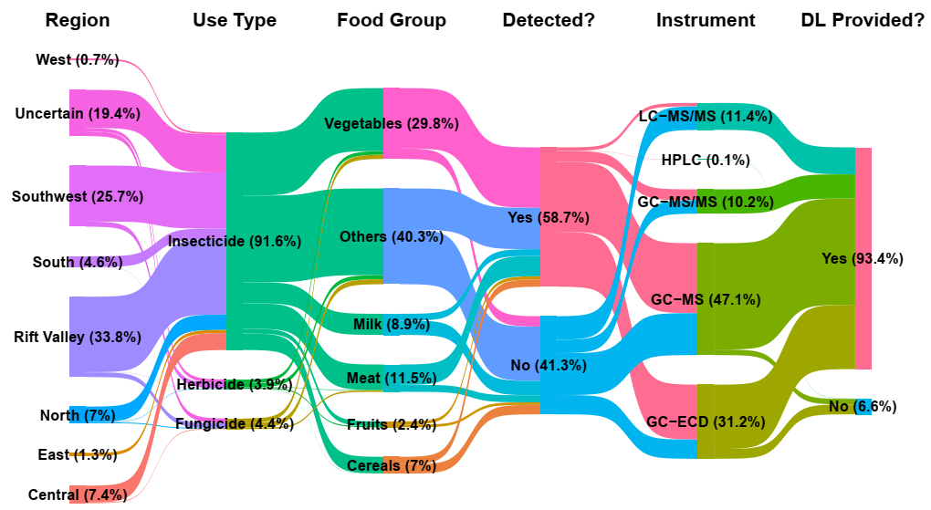

Figure 1: Sankey Diagram illustrating the flow and distribution of pesticide residue detection characteristics across study attributes in Ethiopia.

## National Level Pesticide Residue Concentration

The overall national scale pesticide residue in Ethiopian food was found to be 7.05 µg/kg (95% CI: 4.34,11.46 µg/kg; p < 0.0001) (Table 1). Significant heterogeneity was also observed (dominated by between-study heterogeneity, ~53%), emphasizes that pesticide contamination is not uniform and is influenced by considerable variability across different contexts. The highest concentration was found in fungicides (14.37 µg/kg; 95% CI: 2.54,81.34 µg/kg; p=0.0175) followed by herbicides (14.91 µg/kg; 95% CI: 2.96,75.07 µg/kg; p=0.0103) and insecticides (6.81 µg/kg; 95% CI: 4.13,11.20 µg/kg; p < 0.0001). This pattern might suggest differences in their application rates, persistence characteristics, or metabolic fate within food matrices. Similarly, food group subgroup analysis showed significant differences in concentrations, where milk and others food groups (e.g., honey and khat) appear to have the highest concentrations and fruits and meats show comparatively lower concentrations. Despite fruits and vegetables often being common targets for pesticide application, the lower residue level could reflect factors such as post-harvest processing, metabolic degradation of residues within the food matrix, or specific detection methods employed across studies for these categories.

Overall, findings highlight a significant and widespread presence of pesticide residues in the national food supply, confirming our hypothesis H1. The high heterogeneity also underscores the importance of further meta-regression analysis to identify specific moderators contributing to this variability.

*Food Origin* explained a substantial 10.7% of the observed heterogeneity (𝑅2), followed by *food group* (9.6%), *zone* (4.4%) and *region* (4.3%). These findings partially support our hypothesis (H2) that sample locations (region/zone) and food origins would significantly moderate pesticide residue concentrations, contributing to the observed high heterogeneity. The higher concentrations were found in foods under ‘Others’ category (e.g., honey, khat), and in regions such as South and Southwest. Furthermore, some zones like Bench-Sheko, Gurage, and Hararge exhibited particularly elevated levels, whereas Ilu Aba Bora showed a very low concentration.

However, it is important to note that the marginal R2 values for all moderators were relatively low, indicates the influence of other unmeasured or unmodeled factors contributing to the complex landscape of pesticide residues in Ethiopia. Such factors could include specific pesticide active ingredients, application dosages, agricultural management practices (e.g., pre-harvest intervals), environmental conditions (e.g., soil type, rainfall), post-harvest handling, and local variations in regulatory enforcement or monitoring programs. Challenges with degrees of freedom in robust F-tests for some moderators (e.g., region and zone) due to sparse data in certain categories also suggest limitations in fully capturing their moderating effects in all models.

Table 1: Overall multilevel meta-analysis and meta-regression models summary.

|  |  |  |  |  |  |  |  |  |  |
| --- | --- | --- | --- | --- | --- | --- | --- | --- | --- |
| **Model** | **Subgroup** | **N** | **ES** | **Mean** | **LL** | **UL** | **p val** | **I2 lvl2** | **I2 lvl3** |
| Overall | All Pesticides | 40 | 2099 | 7.05 | 4.34 | 11.46 | **<0.0001** | 49.95 | 50.02 |
| Use Type | Fungicide | 5 | 100 | 14.37 | 2.54 | 81.34 | **0.0175** | 50.47 | 49.5 |
| Herbicide | 8 | 47 | 14.91 | 2.96 | 75.07 | **0.0103** |
| Insecticide | 40 | 1952 | 6.81 | 4.13 | 11.2 | **<0.0001** |
| Food Group | Cereals | 3 | 160 | 12.44 | 7.15 | 21.63 | **0.0026** | 43.52 | 56.44 |
| Fruits | 1 | 46 | 2.6 | 1.09 | 6.19 | 0.0767 |
| Meat | 14 | 230 | 3.34 | 2.14 | 5.21 | **0.0002** |
| Milk | 3 | 200 | 17.39 | 3.74 | 80.89 | 0.0682 |
| Others | 15 | 855 | 17.3 | 9.45 | 31.69 | **<0.0001** |
| Vegetables | 8 | 608 | 3.04 | 1.35 | 6.84 | **0.0375** |
| Instrument | GC-ECD | 12 | 605 | 13.04 | 4.78 | 35.54 | **0.0004** | 50.29 | 49.68 |
| GC-MS | 22 | 1046 | 5.24 | 2.81 | 9.77 | **<0.0001** |
| GC-MS/MS | 3 | 188 | 7.87 | 1.69 | 36.62 | 0.1194 |
| HPLC | 1 | 2 | 9.39 | 2.9 | 30.44 | 0.1666 |
| LC-MS/MS | 2 | 258 | 3.67 | 0.49 | 27.63 | 0.4260 |
| Food Origin | Animal Orgin | 17 | 430 | 4.77 | 2.85 | 7.98 | **<0.0001** | 47.42 | 52.54 |
| Others | 15 | 855 | 13.69 | 7.16 | 26.17 | **<0.0001** |
| Plant Origin | 11 | 814 | 5.51 | 2.23 | 13.61 | **0.0026** |
| Region | Central | 2 | 160 | 8.73 | 3.11 | 24.51 | 0.1517 | 48.37 | 51.59 |
| East | 1 | 28 | 13.86 | 9.25 | 20.77 | **0.0001** |
| North | 6 | 115 | 7.17 | 2.03 | 25.36 | **0.0292** |
| Rift Valley | 16 | 763 | 6.09 | 3.77 | 9.85 | **<0.0001** |
| South | 3 | 98 | 11.85 | 7.6 | 18.47 | **0.0049** |
| Southwest | 10 | 527 | 10.17 | 6.55 | 15.78 | **<0.0001** |
| Uncertain | 4 | 391 | 8.69 | 0.33 | 227.38 | 0.2902 |
| West | 2 | 17 | 1 | 0.01 | 78.19 | 0.9995 |
| Zone | Arsi | 4 | 217 | 5.45 | 2.69 | 11.04 | **0.0010** | 45.47 | 54.49 |
| Bale | 1 | 30 | 11.16 | 6.87 | 18.13 | **0.0001** |
| Bench-Sheko | 1 | 60 | 43.92 | 3.01 | 641.76 | 0.2210 |
| Gambella | 1 | 13 | 7.69 | 6.82 | 8.67 | **0.0191** |
| Gonder | 1 | 28 | 19.9 | 0.03 | 15102.66 | 0.5392 |
| Gurage | 2 | 82 | 17.46 | 9.82 | 31.06 | **0.0103** |
| Hadiya | 1 | 16 | 6.92 | 0.48 | 100.68 | 0.3913 |
| Hararge | 1 | 28 | 20.1 | 12.66 | 31.92 | **0.0001** |
| Ilu Aba Bora | 1 | 4 | 0.09 | 0.07 | 0.12 | **0.0372** |
| Jimma | 9 | 467 | 12.06 | 6.97 | 20.89 | **<0.0001** |
| Lakes | 11 | 164 | 3.16 | 1.78 | 5.62 | **0.0030** |
| Shewa | 7 | 441 | 10.54 | 6.01 | 18.5 | **<0.0001** |
| Sidama | 3 | 103 | 5.83 | 1.68 | 20.21 | 0.1088 |
| Uncertain | 5 | 396 | 12.95 | 0.75 | 222.95 | 0.1584 |
| Wollo | 1 | 50 | 4.49 | 3.7 | 5.45 | **0.0416** |

Table 2: Summary of moderators of pesticide food residue concentrations

|  |  |  |  |
| --- | --- | --- | --- |
| **Moderator** | **LRT** | **P value** | **R2** |
| Food origin | 17.14 | 0.0002 | 0.163 |
| Food group | 29.63 | <0.0001 | 0.079 |
| Zone | 31.21 | 0.0052 | 0.056 |
| Region | 8 | 0.3328 | 0.038 |
| Instrument | 3.01 | 0.5564 | 0.021 |
| Type | 38.64 | <0.0001 | 0.019 |

Approximately *31.3% (65 out of 208)* of pesticide-food combinations exceeded MRL. When aggregated by individual pesticides (Figure 3a), 23 out of 51 pesticides with MRL data showed no MRL exceedance. Conversely, 8 pesticides had MRL exceedance rates greater than 50%, and 4 pesticides (specifically, xx) exhibited MRL exceedance rates of 100%. Similarly, aggregated by food groups (Figure 3b), Fish and Animal Meat food groups had no observed MRL exceedance. However, 5 other food groups (namely, xx) showed MRL exceedance rates greater than 50%, indicating widespread contamination across these dietary categories. No single food group was found to have a 100% MRL exceedance rate.

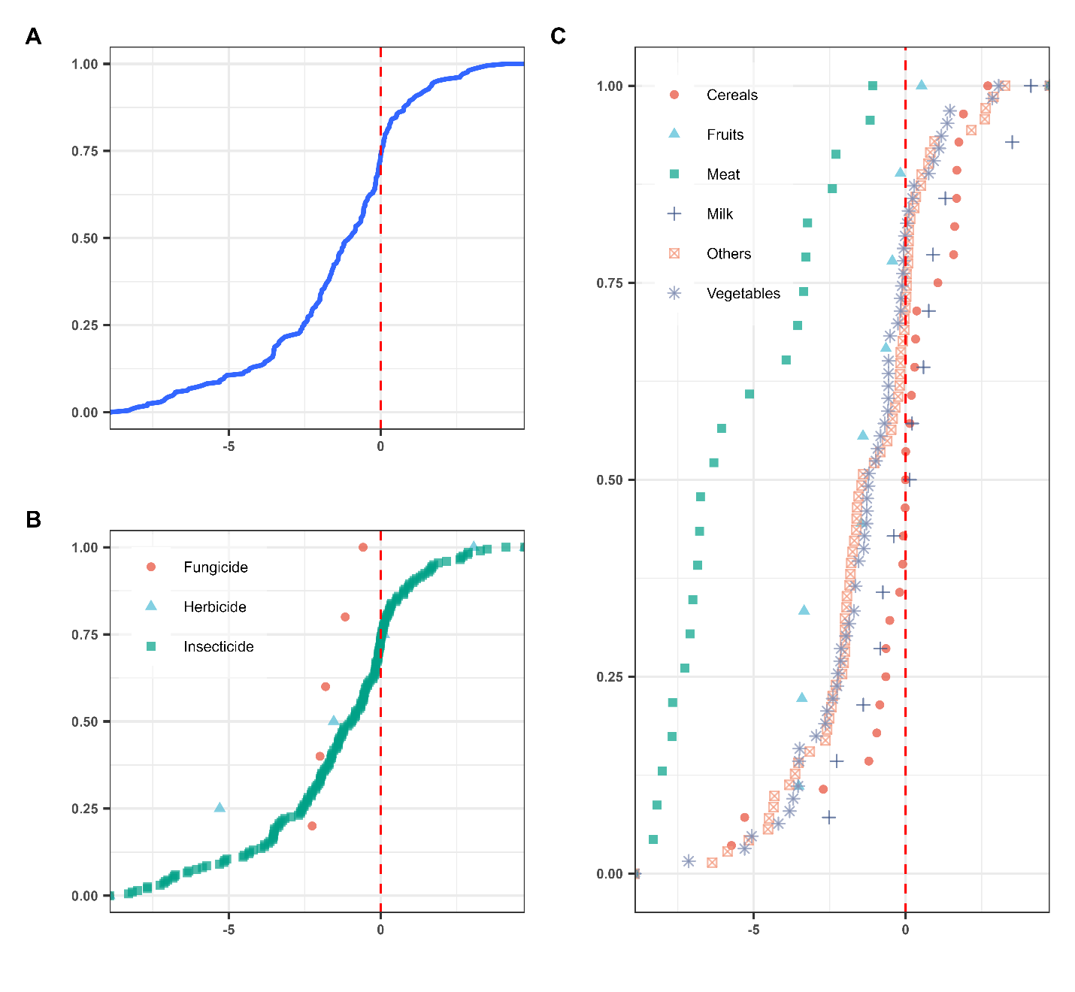

Figure 3: Cumulative distribution function of logarithm of MRL exceedance ratio. A vertical red dashed line at log(1) indicates the threshold for MRL exceedance. Values to the right of this line represent exceedances.

## Dietary Risk Assessments

The probabilistic assessment of chronic health risks, encompassing both non-cancer and cancer risks due to dietary pesticide exposure, is comprehensively summarized in Figure 4 and detailed in Supplementary Table S2.

Non-cancer risks, quantified by the Hazard Quotient (HQ), were assessed for 229 pesticide-food combinations where chronic Toxicity Reference Values (TRVs) were available. While 165 combinations had HQ values below 1 (indicating negligible risk), approximately 28% (64 out of 229) of the assessed combinations exhibited HQ values exceeding 1, signaling a potential for non-cancer health effects (Figure 4, top panel). The analysis identified several critical combinations with 100% HQ exceedance probabilities, meaning all Monte Carlo simulations resulted in an HQ greater than 1. These included pesticide-food pairs involving aldrin, heptachlor epoxide, and p,p'-DDD detected in key dietary items such as corn, millet, rice, sorghum, tea, khat, milk, and drinking water. The most pronounced non-cancer risks were observed for heptachlor epoxide in khat, which presented the highest median HQ of 488.85 (5th–95th percentile range: 125.6–1974.2). This was closely followed by aldrin in corn, with a median HQ of 240.64 (5th–95th percentile range: 59.72–977.46), underscoring substantial potential for adverse non-cancer health outcomes from consuming these contaminated foods.

Cancer risks, expressed as Lifetime Cancer Risk (LCR), were evaluated for 119 pesticide-food combinations for which Oral Slope Factors (OSFs) were available. The World Health Organization (WHO) typically considers an LCR greater than 1×10−6 as unacceptable, with values exceeding 1×10−4 warranting urgent intervention. The probabilistic assessment revealed widespread potential for increased cancer risk (Figure 4, bottom panel). These findings collectively underscore a concerning public health challenge in Ethiopia, with a significant proportion of dietary pesticide exposures potentially contributing to both non-cancer and cancer health risks, particularly from legacy organochlorine pesticides like aldrin and DDT in staple foods and commonly consumed items.

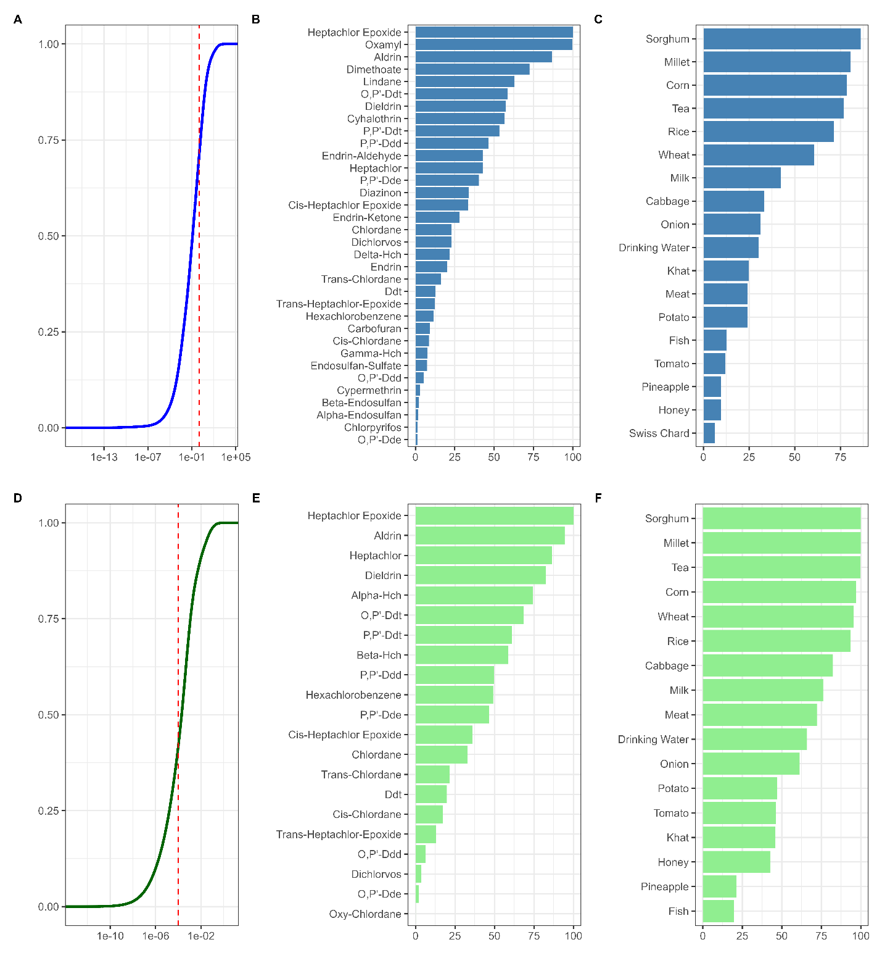

Figure 4: Probabilistic health risk assessment of dietary pesticide exposure. This figure illustrates the cumulative distribution functions for Hazard Quotient (HQ) and Lifetime Cancer Risk (LCR), along with the percentage of HQ and LCR exceedance rates aggregated by pesticide and food categories.

# Conclusion

The high prevalence of MRL exceedance, combined with pooled concentration estimates will be critical inputs for the subsequent dietary health risk assessments. By identifying the types of pesticides, food groups, and geographical areas associated with higher concentrations, our findings provide essential data for informing targeted interventions, improving regulatory frameworks, and developing effective public health strategies to mitigate the risks associated with pesticide exposure in the Ethiopian food supply.

# References

Abbas, M., Abbas, S., Hussain, N., Javeed, M.T., Ghaffar, A., Nadeem, M., Khaliq, M., *et al.* (2024), “Assessment of residues from common pesticides and associated risks in Pakistan”, *Environmental Monitoring and Assessment*, Vol. 196 No. 11, p. 1061, doi: 10.1007/s10661-024-13220-x.

Asefa, E.M., Damtew, Y.T. and Ober, J. (2024), “Pesticide water pollution, human health risks, and regulatory evaluation: A nationwide analysis in Ethiopia”, *Journal of Hazardous Materials*, Vol. 478, doi: 10.1016/j.jhazmat.2024.135326.

Asefa, E.M., Mergia, M.T., Ayele, S., Damtew, Y.T., Teklu, B.M. and Weldemariam, E.D. (2024), “Pesticides in Ethiopian surface waters: A meta-analytic based ecological risk assessment”, *Science of the Total Environment*, Vol. 911, p. 168727, doi: 10.1016/j.scitotenv.2023.168727.

Azur, M.J., Stuart, E.A., Frangakis, C. and Leaf, P.J. (2011), “Multiple imputation by chained equations: What is it and how does it work?”, *International Journal of Methods in Psychiatric Research*, Vol. 20 No. 1, pp. 40–49, doi: 10.1002/mpr.329.

Beyuo, J., Sackey, L.N.A., Yeboah, C., Kayoung, P.Y. and Koudadje, D. (2024), “The implications of pesticide residue in food crops on human health: a critical review”, *Discover Agriculture*, Vol. 2 No. 1, p. 123, doi: 10.1007/s44279-024-00141-z.

Buuren, S. van and Groothuis-Oudshoorn, K. (2011), “mice : Multivariate Imputation by Chained Equations in R”, *Journal of Statistical Software*, Vol. 45 No. 3, pp. 1–67, doi: 10.18637/jss.v045.i03.

Canales, R.A., Wilson, A.M., Pearce-Walker, J.I., Verhougstraete, M.P. and Reynolds, K.A. (2018), “Methods for handling left-censored data in quantitative microbial risk assessment”, *Applied and Environmental Microbiology*, Vol. 84 No. 20, doi: 10.1128/AEM.01203-18.

Carrasco Cabrera, L., Di Piazza, G., Dujardin, B., Marchese, E. and Medina Pastor, P. (2024), “The 2022 European Union report on pesticide residues in food”, *EFSA Journal*, Vol. 22 No. 4, doi: 10.2903/j.efsa.2024.8753.

CSA. (2020), “Socioeconomic Survey 2018-2019 [Data set]”, World Bank, Development Data Group, doi: 10.48529/K739-C548.

Daba, D., Hymete, A., Bekhit, A.A., Mohamed, A.M.I. and Bekhit, A.E.D.A. (2011), “Multi residue analysis of pesticides in wheat and khat collected from different regions of Ethiopia”, *Bulletin of Environmental Contamination and Toxicology*, Vol. 86 No. 3, pp. 336–341, doi: 10.1007/s00128-011-0207-1.

Dinede, G., Bihon, W., Gazu, L., Foukmeniok Mbokou, S., Girma, S., Srinivasan, R., Roothaert, R., *et al.* (2023), “Assessment of pesticide residues in vegetables produced in central and eastern Ethiopia”, *Frontiers in Sustainable Food Systems*, Vol. 7, doi: 10.3389/fsufs.2023.1143753.

EFSA. (2010), “Management of left‐censored data in dietary exposure assessment of chemical substances”, *EFSA Journal*, Vol. 8 No. 3, doi: 10.2903/j.efsa.2010.1557.

Egger, M., Smith, G.D., Schneider, M. and Minder, C. (1997), “Bias in meta-analysis detected by a simple, graphical test”, *British Medical Journal*, Vol. 315 No. 7109, pp. 629–634, doi: 10.1136/bmj.315.7109.629.

El-Sheikh, E.-S.A., Ramadan, M.M., El-Sobki, A.E., Shalaby, A.A., McCoy, M.R., Hamed, I.A., Ashour, M.-B., *et al.* (2022), “Pesticide Residues in Vegetables and Fruits from Farmer Markets and Associated Dietary Risks”, *Molecules*, Vol. 27 No. 22, p. 8072, doi: 10.3390/molecules27228072.

Flinders, C., Barnhart, B., Morrison, E.B., Anderson, P.D. and Landis, W.G. (2025), “Probabilistic approaches for risk assessment and regulatory criteria development: current applications, gaps, and opportunities”, *Integrated Environmental Assessment and Management*, doi: 10.1093/inteam/vjaf016.

Gentil, C., Fantke, P., Mottes, C. and Basset-Mens, C. (2020), “Challenges and ways forward in pesticide emission and toxicity characterization modeling for tropical conditions”, *The International Journal of Life Cycle Assessment*, Vol. 25 No. 7, pp. 1290–1306, doi: 10.1007/s11367-019-01685-9.

Gómez-Carracedo, M.P., Andrade, J.M., López-Mahía, P., Muniategui, S. and Prada, D. (2014), “A practical comparison of single and multiple imputation methods to handle complex missing data in air quality datasets”, *Chemometrics and Intelligent Laboratory Systems*, Vol. 134, pp. 23–33, doi: 10.1016/j.chemolab.2014.02.007.

Handford, C.E., Elliott, C.T. and Campbell, K. (2015), “A review of the global pesticide legislation and the scale of challenge in reaching the global harmonization of food safety standards”, *Integrated Environmental Assessment and Management*, Vol. 11 No. 4, pp. 525–536, doi: 10.1002/ieam.1635.

Helsel, D.R. (2006), “Fabricating data: How substituting values for nondetects can ruin results, and what can be done about it”, *Chemosphere*, Vol. 65 No. 11, pp. 2434–2439, doi: 10.1016/j.chemosphere.2006.04.051.

Ian, R.W., Patrick, R. and W., A.M. (2011), “Multiple imputation using chained equations: Issues and guidance for practice”, *Statistics in Medicine*, Vol. 30 No. 4, pp. 377–399.

Ingenbleek, L., Verger, P., Gimou, M.M., Adegboye, A., Adebayo, S.B., Hossou, S.E., Koné, A.Z., *et al.* (2020), “Human dietary exposure to chemicals in sub-Saharan Africa: safety assessment through a total diet study”, *The Lancet Planetary Health*, Vol. 4 No. 7, pp. e292–e300, doi: 10.1016/S2542-5196(20)30104-2.

Kambach, S., Bruelheide, H., Gerstner, K., Gurevitch, J., Beckmann, M. and Seppelt, R. (2020), “Consequences of multiple imputation of missing standard deviations and sample sizes in meta-analysis”, *Ecology and Evolution*, Vol. 10 No. 20, pp. 11699–11712, doi: 10.1002/ece3.6806.

Khatun, P., Islam, A., Sachi, S., Islam, M.Z. and Islam, P. (2023), “Pesticides in vegetable production in Bangladesh: A systemic review of contamination levels and associated health risks in the last decade”, *Toxicology Reports*, Vol. 11, pp. 199–211, doi: 10.1016/j.toxrep.2023.09.003.

Kim, K.H., Kabir, E. and Jahan, S.A. (2017), “Exposure to pesticides and the associated human health effects”, *Science of the Total Environment*, Vol. 575, pp. 525–535, doi: 10.1016/j.scitotenv.2016.09.009.

Lagisz, M., Yang, Y., Young, S. and Nakagawa, S. (2025), “A practical guide to evaluating sensitivity of literature search strings for systematic reviews using relative recall”, *Research Synthesis Methods*, Vol. 16 No. 1, pp. 1–14, doi: 10.1017/rsm.2024.6.

Lee, M., Saha, A., Sundaram, R., Albert, P.S. and Zhao, S. (2024), “Accommodating detection limits of multiple exposures in environmental mixture analyses: an overview of statistical approaches”, *Environmental Health: A Global Access Science Source*, Vol. 23 No. 1, doi: 10.1186/s12940-024-01088-w.

Mekonen, S., Lachat, C., Ambelu, A., Steurbaut, W., Kolsteren, P., Jacxsens, L., Wondafrash, M., *et al.* (2015), “Risk of DDT residue in maize consumed by infants as complementary diet in southwest Ethiopia”, *Science of the Total Environment*, Vol. 511, pp. 454–460, doi: 10.1016/j.scitotenv.2014.12.087.

Mengistu, D.A., Geremew, A., Tessema, R.A. and Wolfing, T. (2025), “Concentrations of DDT metabolites in different food items and public health risk in Africa regions: systematic review and metal analysis”, *Frontiers in Public Health*, Vol. 13, doi: 10.3389/fpubh.2025.1511012.

Nakagawa, S. and Freckleton, R.P. (2008), “Missing inaction: the dangers of ignoring missing data”, *Trends in Ecology and Evolution*, Vol. 23 No. 11, pp. 592–596, doi: 10.1016/j.tree.2008.06.014.

Nakagawa, S., Johnson, P.C.D. and Schielzeth, H. (2017), “The coefficient of determination R2 and intra-class correlation coefficient from generalized linear mixed-effects models revisited and expanded”, *Journal of the Royal Society Interface*, Vol. 14 No. 134, doi: 10.1098/rsif.2017.0213.

Nakagawa, S., Lagisz, M., Jennions, M.D., Koricheva, J., Noble, D.W.A., Parker, T.H., Sánchez-Tójar, A., *et al.* (2022), “Methods for testing publication bias in ecological and evolutionary meta-analyses”, *Methods in Ecology and Evolution*, Vol. 13 No. 1, pp. 4–21, doi: 10.1111/2041-210X.13724.

Nakagawa, S., Lagisz, M., O’Dea, R.E., Pottier, P., Rutkowska, J., Senior, A.M., Yang, Y., *et al.* (2023), “orchaRd 2.0: An R package for visualising meta-analyses with orchard plots”, *Methods in Ecology and Evolution*, Vol. 14 No. 8, pp. 2003–2010, doi: 10.1111/2041-210X.14152.

Nakagawa, S., Yang, Y., Macartney, E.L., Spake, R. and Lagisz, M. (2023), “Quantitative evidence synthesis: a practical guide on meta-analysis, meta-regression, and publication bias tests for environmental sciences”, *Environmental Evidence*, Vol. 12 No. 1, p. 8, doi: 10.1186/s13750-023-00301-6.

Nielsen, G.H., Heiger-Bernays, W.J., Levy, J.I., White, R.F., Axelrad, D.A., Lam, J., Chartres, N., *et al.* (2023), “Application of probabilistic methods to address variability and uncertainty in estimating risks for non-cancer health effects”, *Environmental Health: A Global Access Science Source*, Vol. 21, doi: 10.1186/s12940-022-00918-z.

Van den Noortgate, W., López-López, J.A., Marín-Martínez, F. and Sánchez-Meca, J. (2013), “Three-level meta-analysis of dependent effect sizes”, *Behavior Research Methods*, Vol. 45 No. 2, pp. 576–594, doi: 10.3758/s13428-012-0261-6.

Perobelli, J.E. (2025), “Pesticides and public health: discussing risks in Brazilian agro-industrial growth”, *Frontiers in Toxicology*, Vol. 7, doi: 10.3389/ftox.2025.1442801.

Pustejovsky, J. (2017), “clubSandwich: Cluster-Robust (Sandwich) Variance Estimators with Small-Sample Corrections. R Package Version 0.2”, p. 3.

Pustejovsky, J.E. and Tipton, E. (2022), “Meta-analysis with Robust Variance Estimation: Expanding the Range of Working Models”, *Prevention Science*, Vol. 23 No. 3, pp. 425–438, doi: 10.1007/s11121-021-01246-3.

Sang, C., Niu, Y., Gao, Q., Zhang, J., An, W., Shao, B. and Yang, M. (2024), “Characterizing the cumulative health risks of 19 kinds of pesticides in Chinese food from the cancer and non-cancer perspective”, *Journal of Environmental Management*, Vol. 351, p. 119813, doi: 10.1016/j.jenvman.2023.119813.

Tang, F.H.M., Lenzen, M., McBratney, A. and Maggi, F. (2021), “Risk of pesticide pollution at the global scale”, *Nature Geoscience*, Vol. 14 No. 4, pp. 206–210, doi: 10.1038/s41561-021-00712-5.

Tang, F.H.M., Malik, A., Li, M., Lenzen, M. and Maggi, F. (2022), “International demand for food and services drives environmental footprints of pesticide use”, *Communications Earth and Environment*, Vol. 3 No. 1, p. 272, doi: 10.1038/s43247-022-00601-8.

Tang, F.H.M., Wyckhuys, K.A.G., Li, Z., Maggi, F. and Silva, V. (2025), “Transboundary impacts of pesticide use in food production”, *Nature Reviews Earth & Environment*, Vol. 6 No. 6, pp. 383–400, doi: 10.1038/s43017-025-00673-y.

Teklu, B.M., Adriaanse, P.I., Ter Horst, M.M.S., Deneer, J.W. and Van den Brink, P.J. (2015), “Surface water risk assessment of pesticides in Ethiopia”, *Science of the Total Environment*, Vol. 508, pp. 566–574, doi: 10.1016/j.scitotenv.2014.11.049.

Tipton, E. and Pustejovsky, J.E. (2015), “Small-Sample Adjustments for Tests of Moderators and Model Fit Using Robust Variance Estimation in Meta-Regression”, *Journal of Educational and Behavioral Statistics*, Vol. 40 No. 6, pp. 604–634, doi: 10.3102/1076998615606099.

US EPA. (2000), “Assigning values to non-detected/non-quantified pesticide residues in human health food exposure assessments”, No. 6047, pp. 1–25.

US EPA. (2014), “Risk Assessment Forum White Paper: Probabilistic Risk Assessment Methods and Case Studies. EPA/100/R-14/004”, No. July, p. 98.

USDA. (2024), “Pesticide Data Program Annual Summary - 2023”, p. 246.

Viechtbauer, W. (2010), “Conducting Meta-Analyses in R with the metafor Package”, *Journal of Statistical Software*, Vol. 36 No. 3, pp. 1–48, doi: 10.18637/jss.v036.i03.

Westgate, M. and Grames, E. (2020), “Package ‘synthesisr’”, *R Project*.

Whaley, P., Halsall, C., Ågerstrand, M., Aiassa, E., Benford, D., Bilotta, G., Coggon, D., *et al.* (2016), “Implementing systematic review techniques in chemical risk assessment: Challenges, opportunities and recommendations”, *Environment International*, Vol. 92–93, pp. 556–564, doi: 10.1016/j.envint.2015.11.002.

WHO/FAO. (2009), “Principles and Methods for the Risk Assessment of Chemicals in Food”, *International Journal of Environmental Studies*, pp. 1–7.

Yang, M., Wang, Y., Yang, G., Wang, Y., Liu, F. and Chen, C. (2024), “A review of cumulative risk assessment of multiple pesticide residues in food: Current status, approaches and future perspectives”, *Trends in Food Science and Technology*, Vol. 144, doi: 10.1016/j.tifs.2024.104340.

Yang, Y., Lagisz, M. and Nakagawa, S. (2025), “Visualization toolkits for enriching meta-analyses through evidence maps, bibliometrics, and alternative impact metrics”, *Research Synthesis Methods*, Vol. 16 No. 1, pp. 15–29, doi: 10.1017/rsm.2024.3.